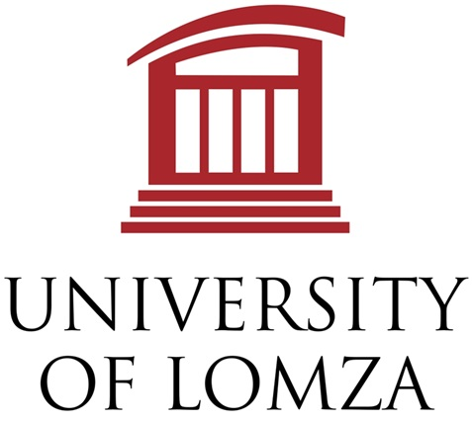

International Scientific Conference
Innovation Trends
Lomza, May 31st 2025
POLAND

REGISTRATION FORM

Surname
First name Title
Institution name
Street No.
City Post code Country
EIN/ ID of the institution
TIN of the institution (tax ID)
E-mail
Phone / Mobile
Paper title

Co-authors

 | Select your conference registration fee | Price
◻ | Registration fee A  Includes personal participation in plenary or poster session, coffee breaks,  banquet admission fee, publications (Conference Proceedings IT2025  and paper in Monograph Innovation Trends 2025) | 80 €/320 zł
◻ | Registration fee B  Includes personal participation, coffee breaks, publications (Conference Proceedings IT2025 and paper in Monograph Innovation Trends 2025) | 40 €/160
◻ | Registration fee C  Online participation in plenary or poster session, publications (Proceedings IT2025  and paper in Monograph Innovation Trends 2025) | 20 €/80 zł
◻ | Publications only (Conference Proceedings IT2025  and paper in Monograph Innovation Trends 2025) | 15 €/60 zł
◻ | Conference Publication in Proceedings IT2025 only | 5 €/20 zł
◻ | Banquet admission fee (for accompanying people) on May 31, 2025 | 40 €/160 zł per person
Use a ☒ or a to indicate your choice of a conference section and a registration fee.
Please, specify the number of required Conference publications, if applicable.
Please, send a separate registration form for each person accompanying you at the banquet.
Important: organizers do not provide accommodation!
You will find a list of hotels you can stay in on website: it2025.al.edu.pl

IT2025 Conference Bank transfer information for € or zł
Transfer description: IT2025 surname and name of participant
Bank Account: IBAN: PL 46 2490 0005 0000 4600 5509 4822
Alior Bank ul. Łopuszańska 38D, 02-232 Warszawa
SWIFT CODE: ALBPPLPW
Beneficiary information: University of Lomza, Akademicka str.14, 18-400 Lomza, NIP: 718-19-47-148

Registration form to be e-mailed or sent by post to
Mgr Marlena Włodkowska  IT2025 Conference Secretary  e-mail: it2025@al.edu.pl  Phone +48 862155488 | Dr Rysard Szczebiot  IT2025 Chairman  e-mail: rysbiot@al.edu.pl  Phone +48 696437040
IT2025 Conference Secretary (regular post)
University of Lomza, ul. Akademicka 14, 18-400 Lomza, Poland

